

Final Year Project Report

Title: Smart Automated Classroom Attendance System Using Face Recognition

Submitted by

Muhammad Ahmed (13460) (Team Leader)
Faiq Ali Siddiqui (14020)
Syeda Aliza Ali (13550)
Maryam Rehan (13541)

Instructor

Dr. Aarij Mahmood Hussaan

Supervisor

Dr. Affan Alim

Project Description

Abstract:

The project aims to develop an automated attendance system for classrooms using camera equipped with facial recognition technology. Traditional attendance tracking methods often suffer from inefficiencies, such as manual recording errors and time-consuming processes. By leveraging cameras and advanced facial recognition algorithms, this system offers a more accurate, efficient, and convenient way to monitor student attendance in educational settings. The system logs attendance in real-time, provides notifications of anomalies.

- Introduction:

In today's fast-paced educational environment, efficient management of classroom attendance poses a significant challenge for educators and administrators alike. Traditional methods of attendance taking, such as manual roll calls or paper-based sign-in sheets, are time-consuming, prone to errors, and often lack real-time insights into student attendance patterns. To address these challenges and streamline the attendance tracking process, we propose the "Smart Automated Classroom Attendance System."
The Smart Automated Classroom Attendance System (SACAS) leverages cutting-edge technology, including Machine learning/Deep learning, based on biometric recognition and computer vision, to revolutionize the way attendance is managed in educational institutions. By harnessing the power of advanced algorithms and sensor technology, the system offers a seamless and efficient solution for tracking student attendance in real-time. Essentially, a database will be integrated to the system for recording the attendance and other in out of the activities of students. The flow diagram of the complete proposed system is shown in Figure -1.
Essentially, the system comprises six primary implementation modules: (i) Creation of the database using registration, (ii) Developing the Machine learning model using available class database, (iii) Detection and recognition of the faces, (iv) Design of the database for attendance records, (v) Integration of the camera, and (vi) User interface development for image registration. Ultimately, each module within the proposed models will be harmoniously integrated to function as a cohesive product. The experiment will be tested on two different senior of dataset (i) already available face dataset like FERET, or Georgia tech, and other is our classroom student’s dataset. You Only Look Once (YOLO): YOLO is another fast and accurate object detection algorithm. It divides the input image into a grid and predicts bounding boxes and class probabilities directly from the grid cells, resulting in real-time performance. ResNet: Residual Networks (ResNet) are a family of CNN architectures featuring residual connections, which allow for the training of very deep networks. ResNet variants are commonly used for face detection and recognition tasks due to their excellent performance and scalability. Therefore, both deep learning techniques will be used in our proposed framework of SACAS. The attendance record will be maintained in MySQL database. A smart attendance database will be designed in MySQL where the attendance activity will be maintained.

Functional Requirements:

- Camera Integration:
The system shall integrate with cameras installed in the classroom to capture real-time footage of the students present in the class.

- Face Recognition:
The system shall employ facial recognition algorithms to accurately identify students who is present in the classroom.

- Attendance Logging:
The system shall automatically log the attendance of each student based on their presence in the classroom captured by cameras.

- Camera Support:
The system shall support two cameras if the classroom is equipped with more than one camera for comprehensive coverage for the students to capture their faces using machine learning and deep learning approach.

- User Interface:
The system shall have a user-friendly interface for teachers/administrators to view attendance records, monitor real-time attendance, and manage the system.

- Time Threshold for Attendance:
The system should define a time threshold to determine if a student who enters the classroom is considered present. For instance, if a student enters the classroom but leaves shortly after without attending most of the class, the system should not mark them as present.

- Guest Management:
The system should have a mechanism to account for guests or visitors in the classroom who are not enrolled in the course.

- Data Export:
The system should allow for the export of attendance data in various formats (e.g., CSV, Excel) for further analysis or record-keeping.

Non-Functional Requirements:

- Accuracy:
The facial recognition algorithm shall achieve a minimum accuracy rate of 85%-90% in identifying students present in the classroom.

- Maintainability:
The system shall be designed in a modular fashion to facilitate easy updates and maintenance.

- Interoperability:
The system should be capable of exporting data in any format (e.g., CSV, Excel) to ensure compatibility with various data analysis tools.

- Cost-effectiveness:
The system should be developed and implemented in a cost-effective manner, considering factors like hardware, software, and maintenance requirements.

- Auditability:
The system shall maintain detailed logs of attendance records, including timestamps of when students were recognized and logged.

- Data Integrity:
The system shall ensure that all attendance data is accurately captured, stored, and retrieved without any corruption or loss.

- User Support:
The system shall provide comprehensive user support, including help documentation, tutorials, and a dedicated support channel for teachers and administrators to resolve issues quickly.

- Response Time::
The system's response time for facial recognition and attendance logging shall be optimized to ensure minimal delay, especially during peak usage hours.

Diagrams:

Use Case Diagram:

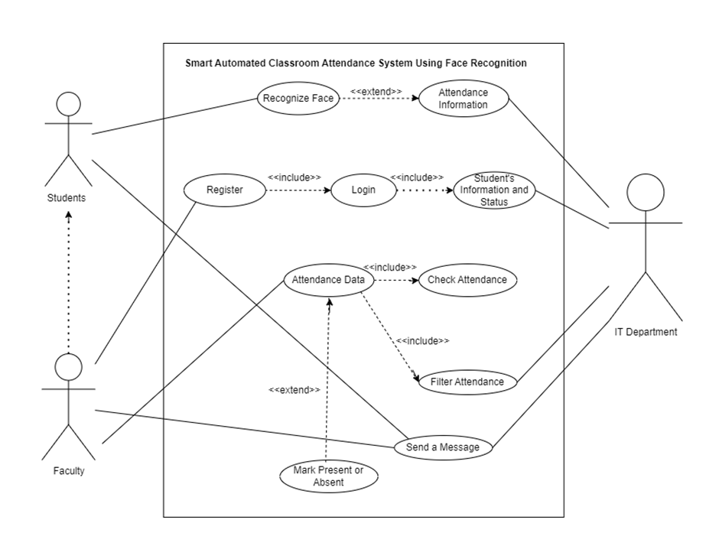

Use Case Narratives:

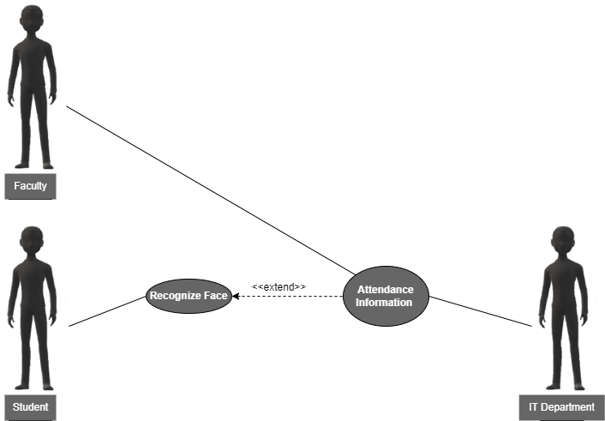

Use Case Name: | Automatic Attendance Marking (UC-1)
ID: | UC-1
Actors Involved: | - Student  - IT  - Faculty
Brief Description | It describes the automatic process of marking a student's attendance using facial recognition technology.
Pre-Conditions | - Student registered with face image data  - Classroom camera operational  - Attendance system software working.
Post-Conditions | Student attendance recorded with timestamp.  Faculty manages records.
Normal Flow of Events: | Actor Action | System Response
Normal Flow of Events: | Student’s Action:  - Enters the classroom and the student does not need to take any specific actions beyond being present within the camera's view for facial recognition to occur. | - Face Recognition  - Attendance Marking

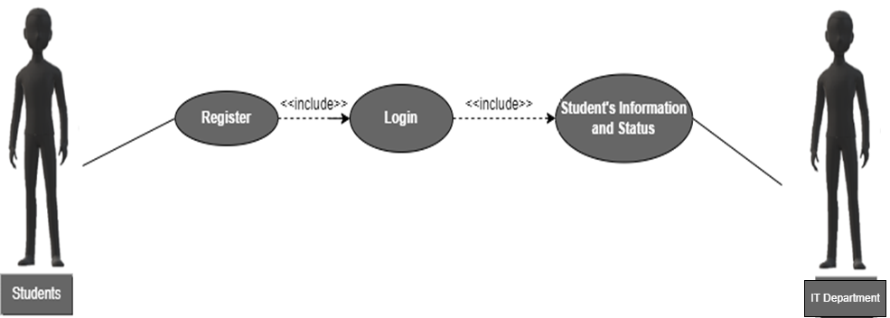

Use Case Name: | Faculty Manages Student Information (UC-2)
ID: | UC-2
Actors Involved: | • Faculty  • IT (Indirect)
Brief Description | It describes the process of a faculty member registering, logging in, and managing student information within the attendance system.
Pre-Conditions | • The faculty member has internet access and a device to access the system.  • The attendance system software is operational.
Post-Conditions | • The faculty member is successfully registered and logged in to the system.  • The faculty member can view and manage student information and status (e.g., attendance records).  • (Indirect) IT retains control over overall system management and security.
Normal Flow of Events: | Actor Action | System Response
Normal Flow of Events: | 1. Faculty:  - Registers on system page.  - Logs in with username/password  - Manages student info on faculty dashboard: views lists, individual details, attendance (if permitted), updates (if permitted).  - IT(Indirect):  - IT maintains security, defines permissions. | 1. System creates faculty account securely.  2. Displays student info based on access level.  3. Grants access to a system with valid login.  4. Prompts retry or recovery for invalid credentials.

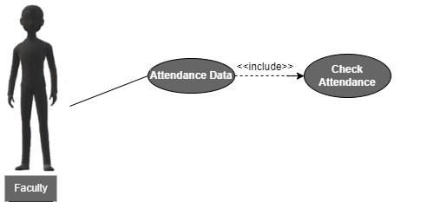

Use Case Name: | Faculty Checks Attendance (UC-3)
ID: | UC-3
Actors Involved: | • Faculty
Brief Description | This use case describes the process of a faculty member using the system to view and check student attendance data.
Pre-Conditions | • The faculty member is successfully logged in to the system.  • The attendance system has captured student attendance data (e.g., through face recognition).
Post-Conditions | • The faculty member has viewed and analyzed student attendance information for a specific class session or timeframe.
Normal Flow of Events: | Actor Action | System Response
Normal Flow of Events: | Faculty:  Accesses the attendance data section of the system.  Selects options to view and analyze attendance data for a specific class session, date range, or student. | 1. System displays attendance options.  2. Faculty filter class/date/student.  3. System retrieves attendance info: student list, status (present/absent/late), timestamps. Format depends on system design.

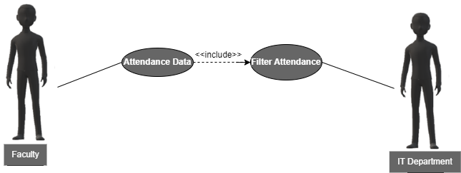

Use Case Name: | Faculty Filters Attendance Data (UC-4)
ID: | UC-4
Actors Involved: | • Faculty  • IT (Indirect)
Brief Description | This use case describes the process of a faculty member using the system to filter and view specific student attendance data.
Pre-Conditions | • The faculty member is successfully logged in to the system.  • The attendance system has captured student attendance data.
Post-Conditions | • The faculty member has viewed and analyzed student attendance information based on applied filters (e.g., date range, specific student).
Normal Flow of Events: | Actor Action | System Response
Normal Flow of Events: | Faculty:  Accesses the attendance data section of the system.  Selects options to view and analyze attendance data for a specific class session, date range, or student. | 1. System displays attendance options.  2. Faculty filters class/date/student.  3. System retrieves attendance info: student list, status (present/absent/late), timestamps. Format depends on system design.

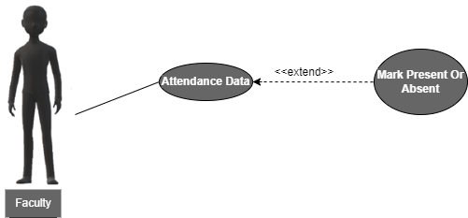

Use Case Name: | Faculty Initiates And Checks For Students Attendance(UC-5)
ID: | UC-5
Actors Involved: | • Faculty
Brief Description | This use case describes the process of a faculty member using the system to mark student attendance during a class session.
Pre-Conditions | • The faculty member is successfully logged in to the system.  • The face recognition system is operational.
Post-Conditions | • The faculty member also have option to mark (present or absent), if student’s were present in the class.  • The system stores the attendance data for each student.
Normal Flow of Events: | Actor Action | System Response
Normal Flow of Events: | Faculty Actions:  • Accesses attendance marking section.  • Selects method to mark attendance:  - Manual selection: Selects attendance status(present/absent) for each student. | 1. Facial Recognition:  - Successful recognition marks student "present" with date/time.  - Unsuccessful recognition prompts manual selection or retry.  Manual Selection:  - Stores faculty's selections for each student's status with date/time.

Machine Learning Pipeline

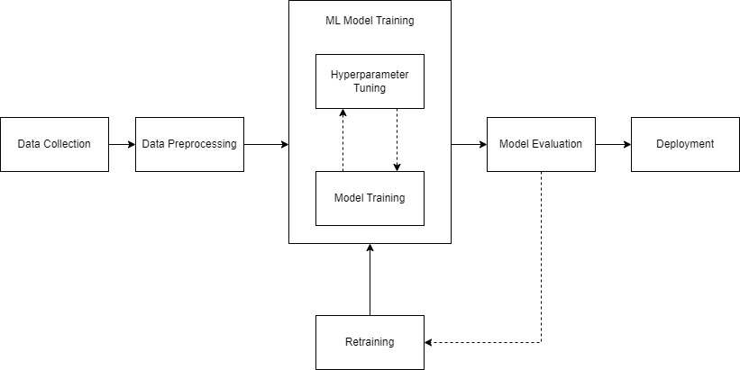

ERD Diagram

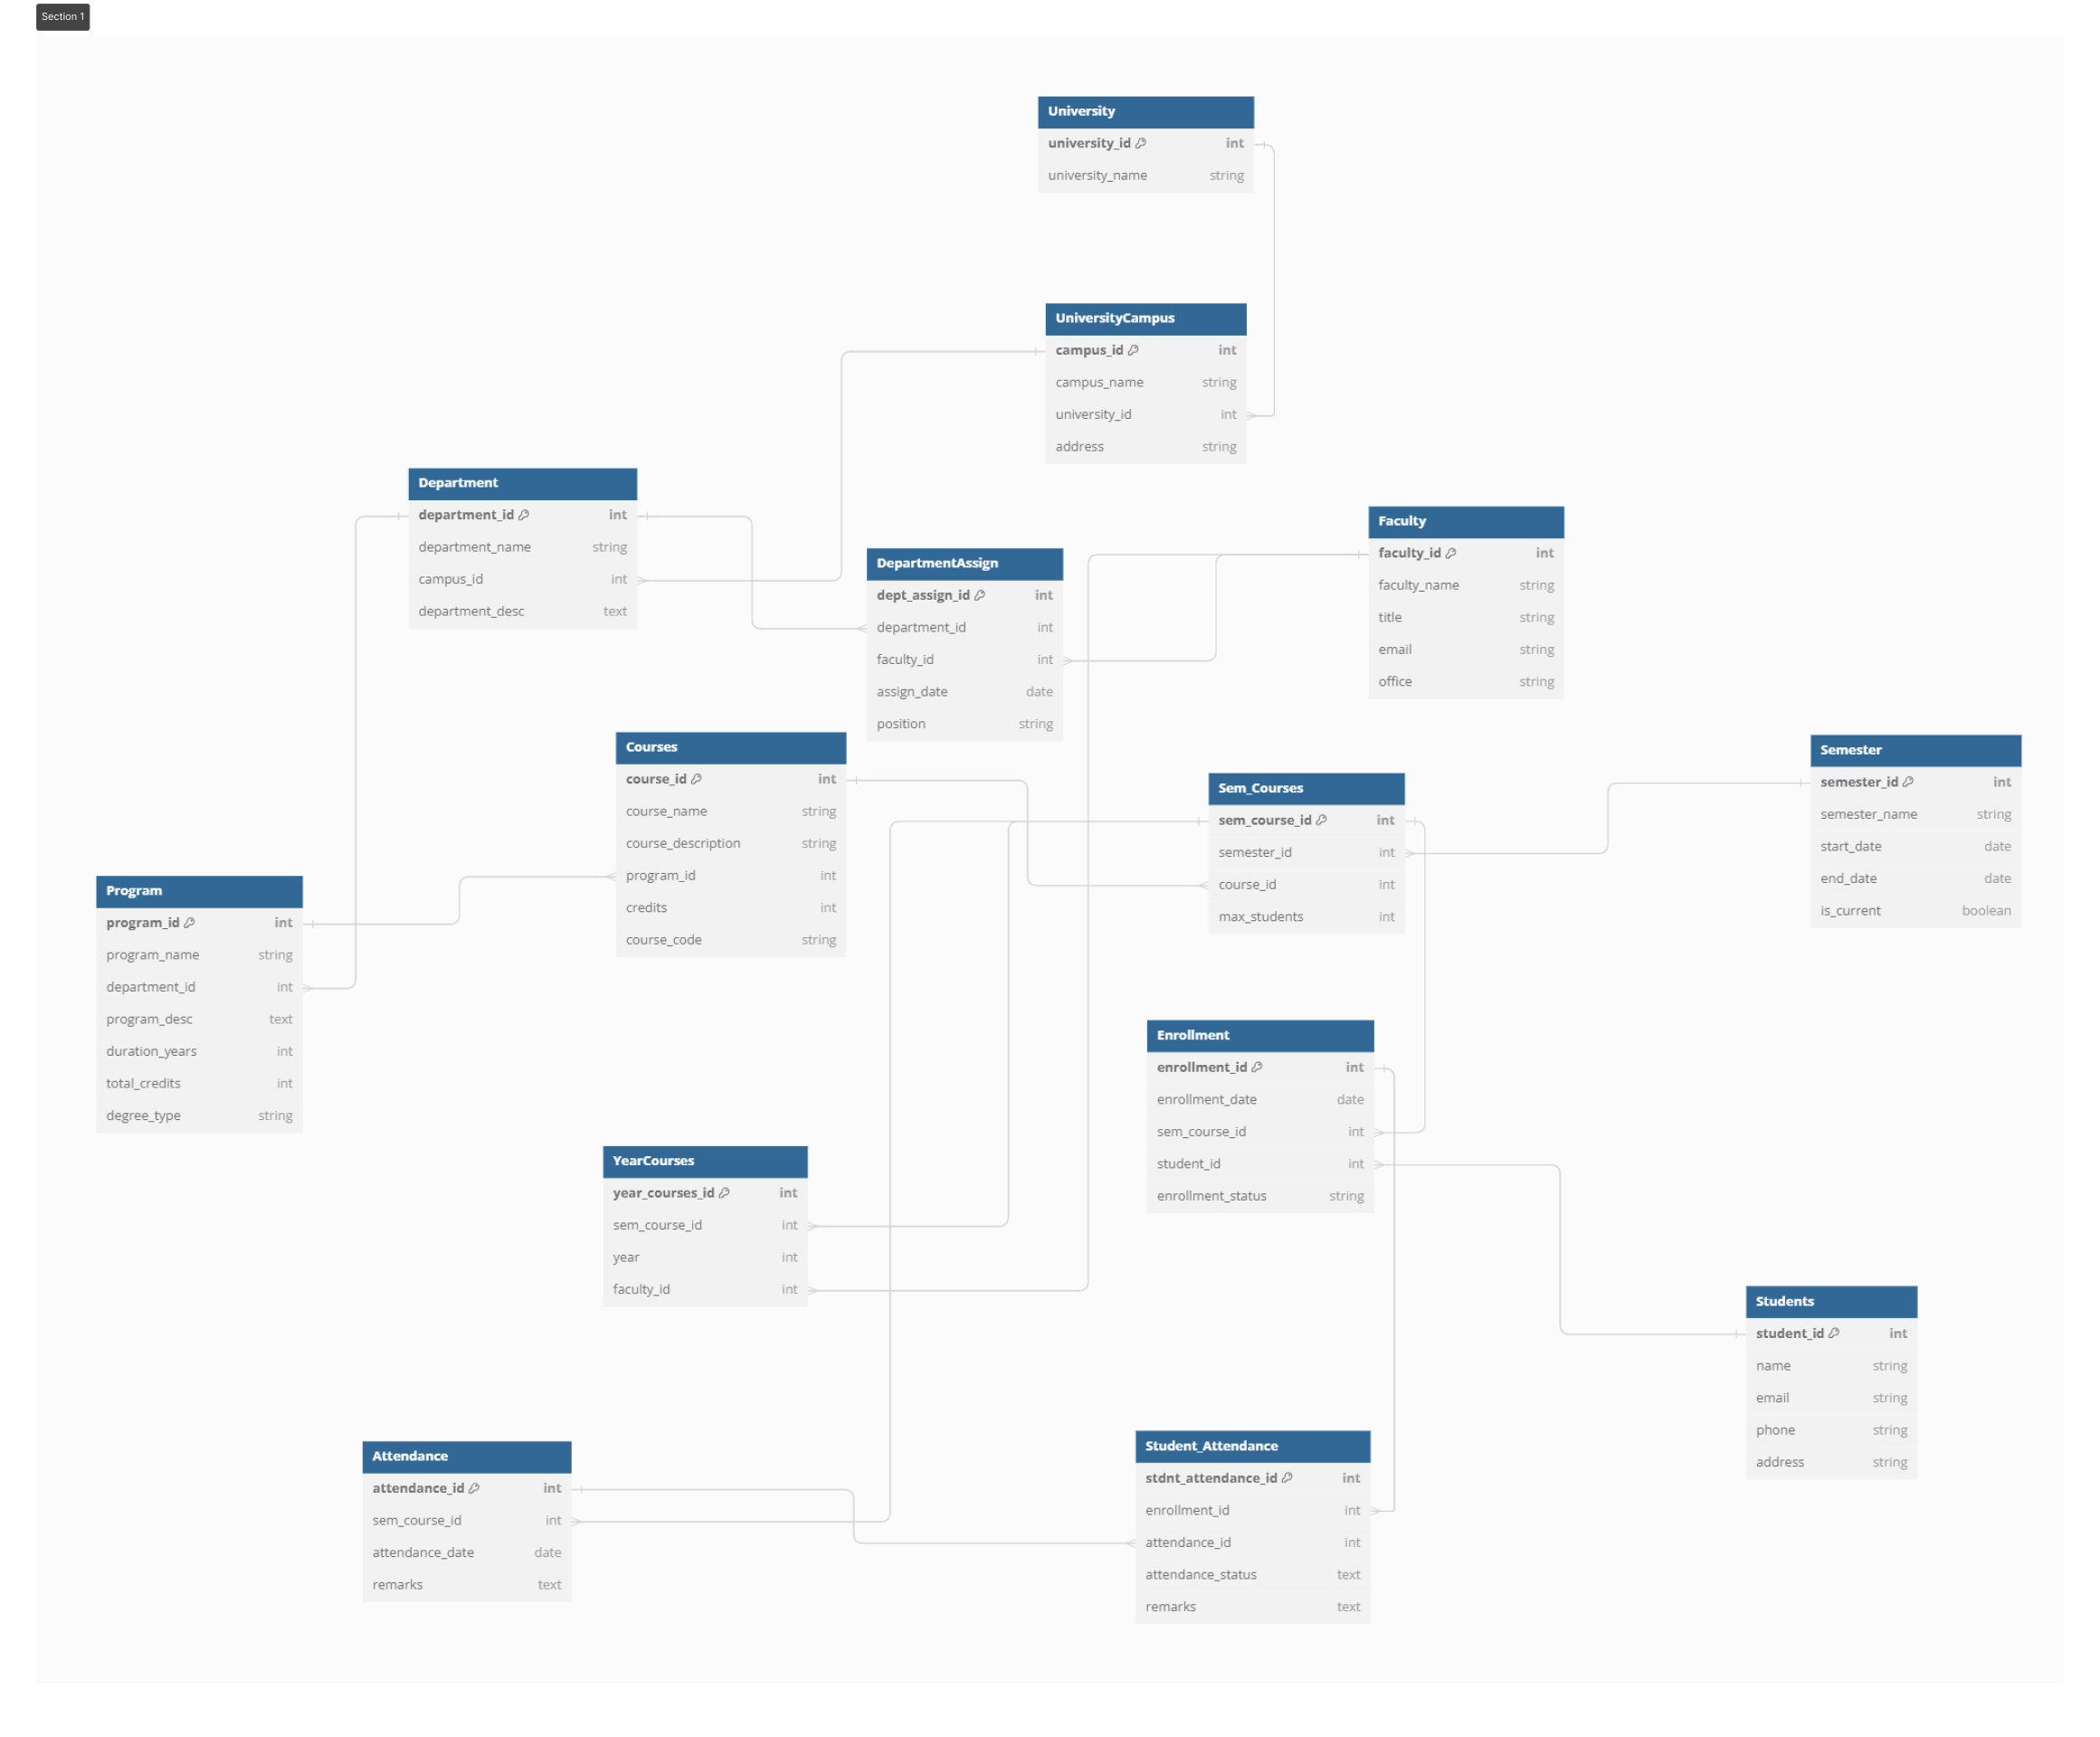

State Diagram

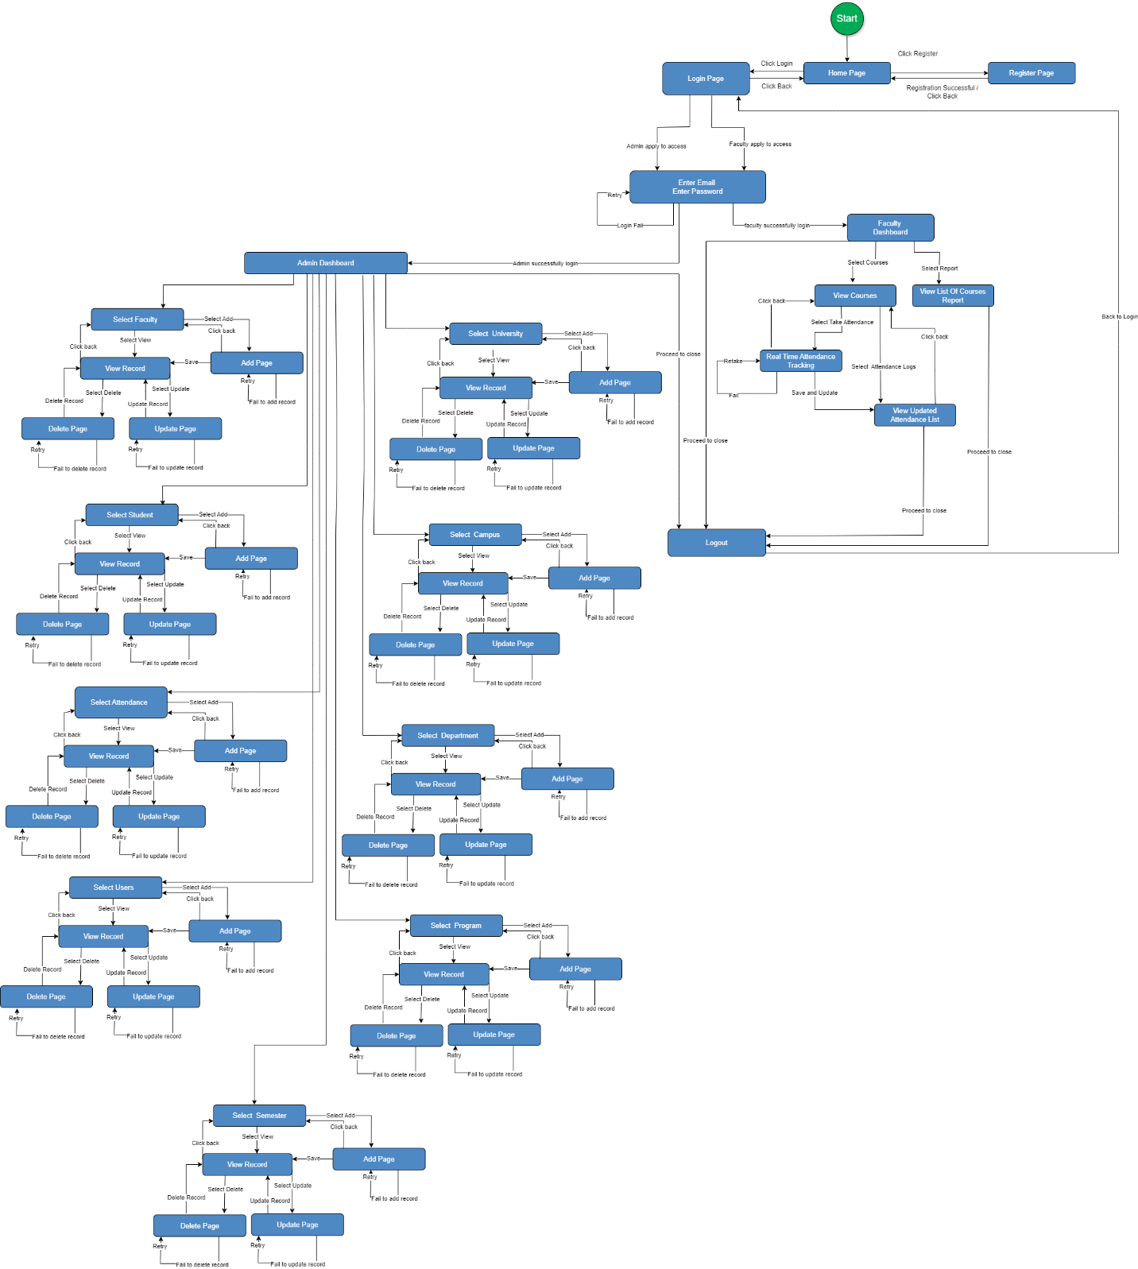

Prototype:

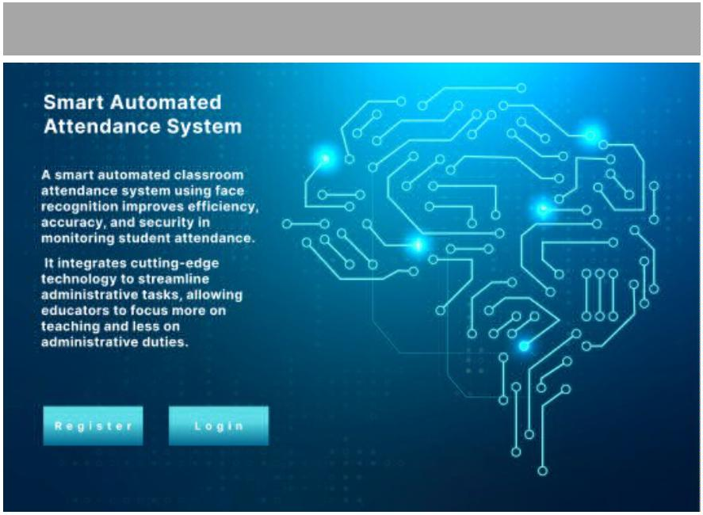
Home Page

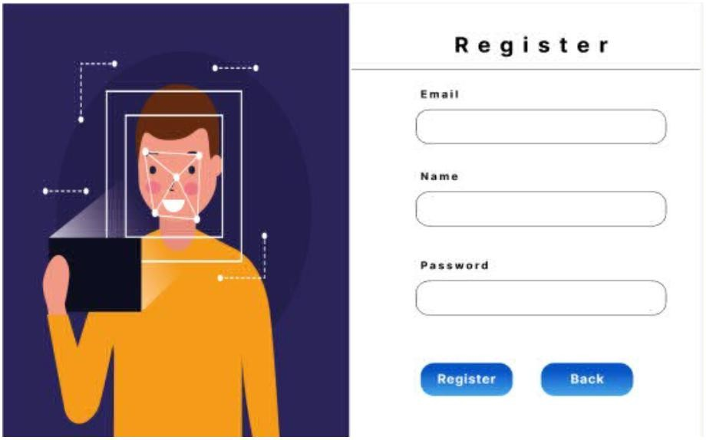
Register

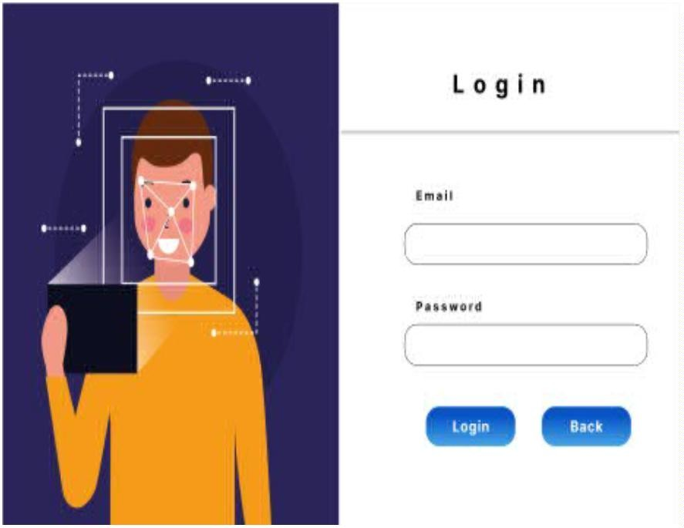
Login

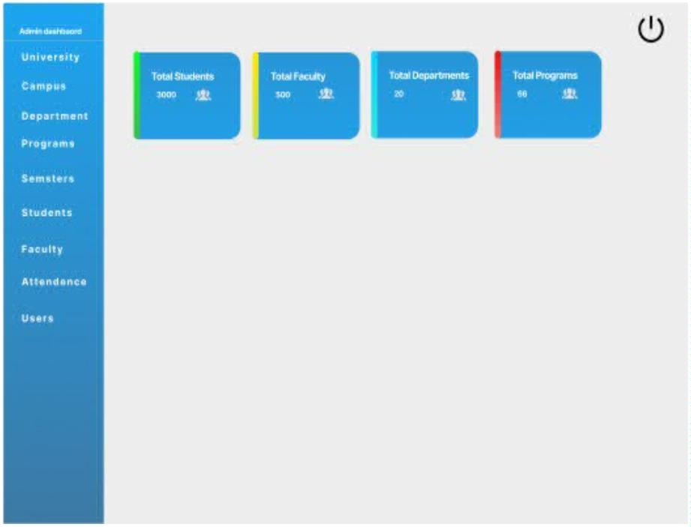
Admin Dashboard

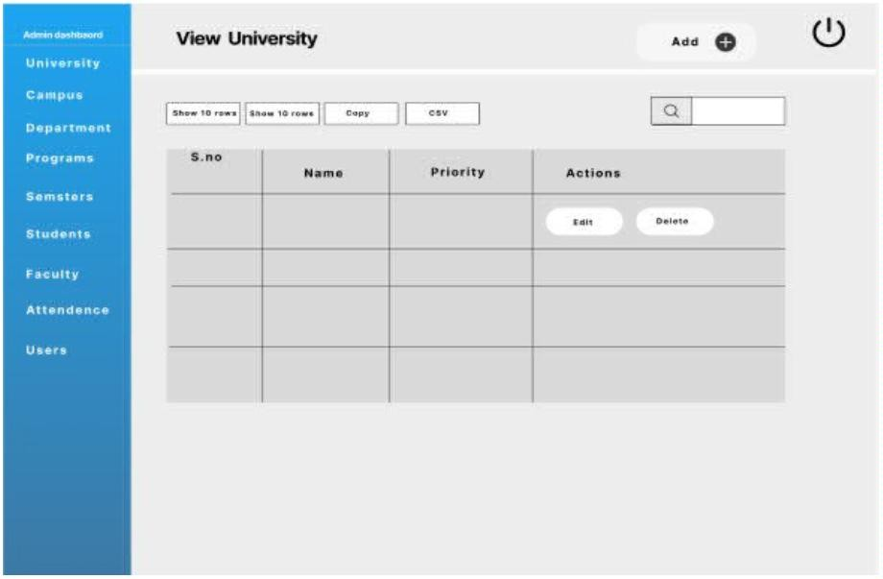

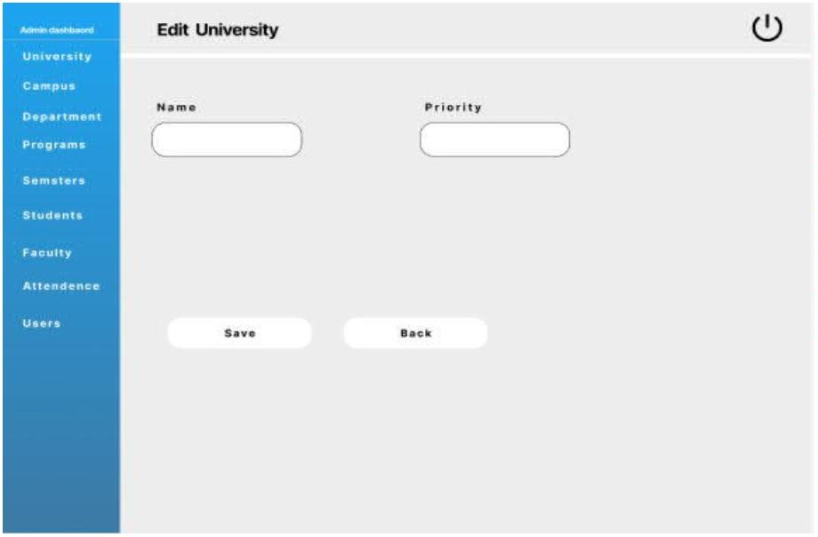

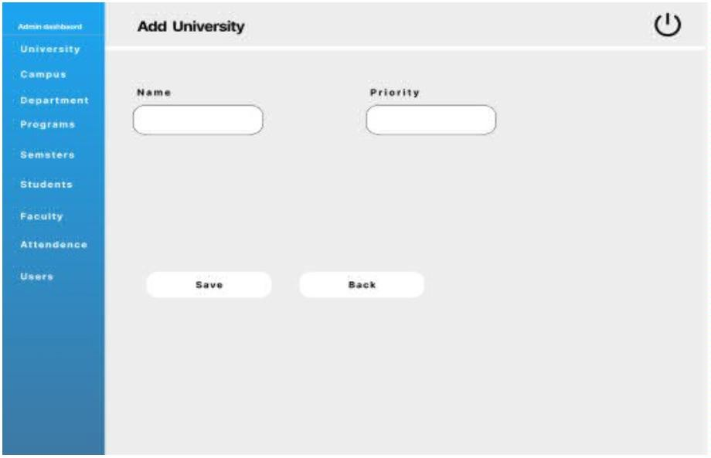

Faculty Dashboard
